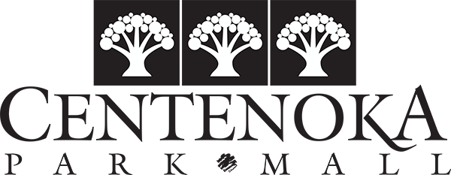
CHRISTMAS CRAFT FAIR
REGISTRATION
December 3rd and 4th, 2022
Name: _________________________________________________
Phone #: (where you can be reached during the day) ________________________
Email: __________________________________________
Craft Products: ________________________________________________________________________________________________________________________________________________________________________________

Please check the boxes below for days you will be at the Mall selling your items:

DAYS & TIMES: SATURDAY: 9:00 am to 5:00 pm
SUNDAY: 11:00 am to 3:30 pm

# of Tables Needed: ____________ (includes 1 8’ table)

# of Chairs Needed: ____________
Payment:

ALL DAY: $18.57 + GST = $20.00 per table (additional tables $10.00 each) Works out to $20.00 per day per table if you don’t want any extra tables)

CASH: ______ CHEQUE: _______

Total must be paid in advance to Administration Office in the Mall no later than November 30th. Office hours at 8:30 to 4:30 pm Monday to Friday – closed stats and weekends. Please email Brittney if there are any questions or concerns at cpmreception@gmail.com.

Vendor Signature: ________________________________________
Approved By: ________________________________________

*Centenoka Park Mall is in no way responsible for any merchandise that is damaged, lost or stolen. If the vendor leaves the table overnight, Saturday December 3rd, it is the Vendor’s responsibility to cover the table(s)/products with their own material ie. Sheet or blanket.

